Activity 1

Pig file for episodeIV_dialouges.txt

Output Pig for episodeIV_dialouges.txt

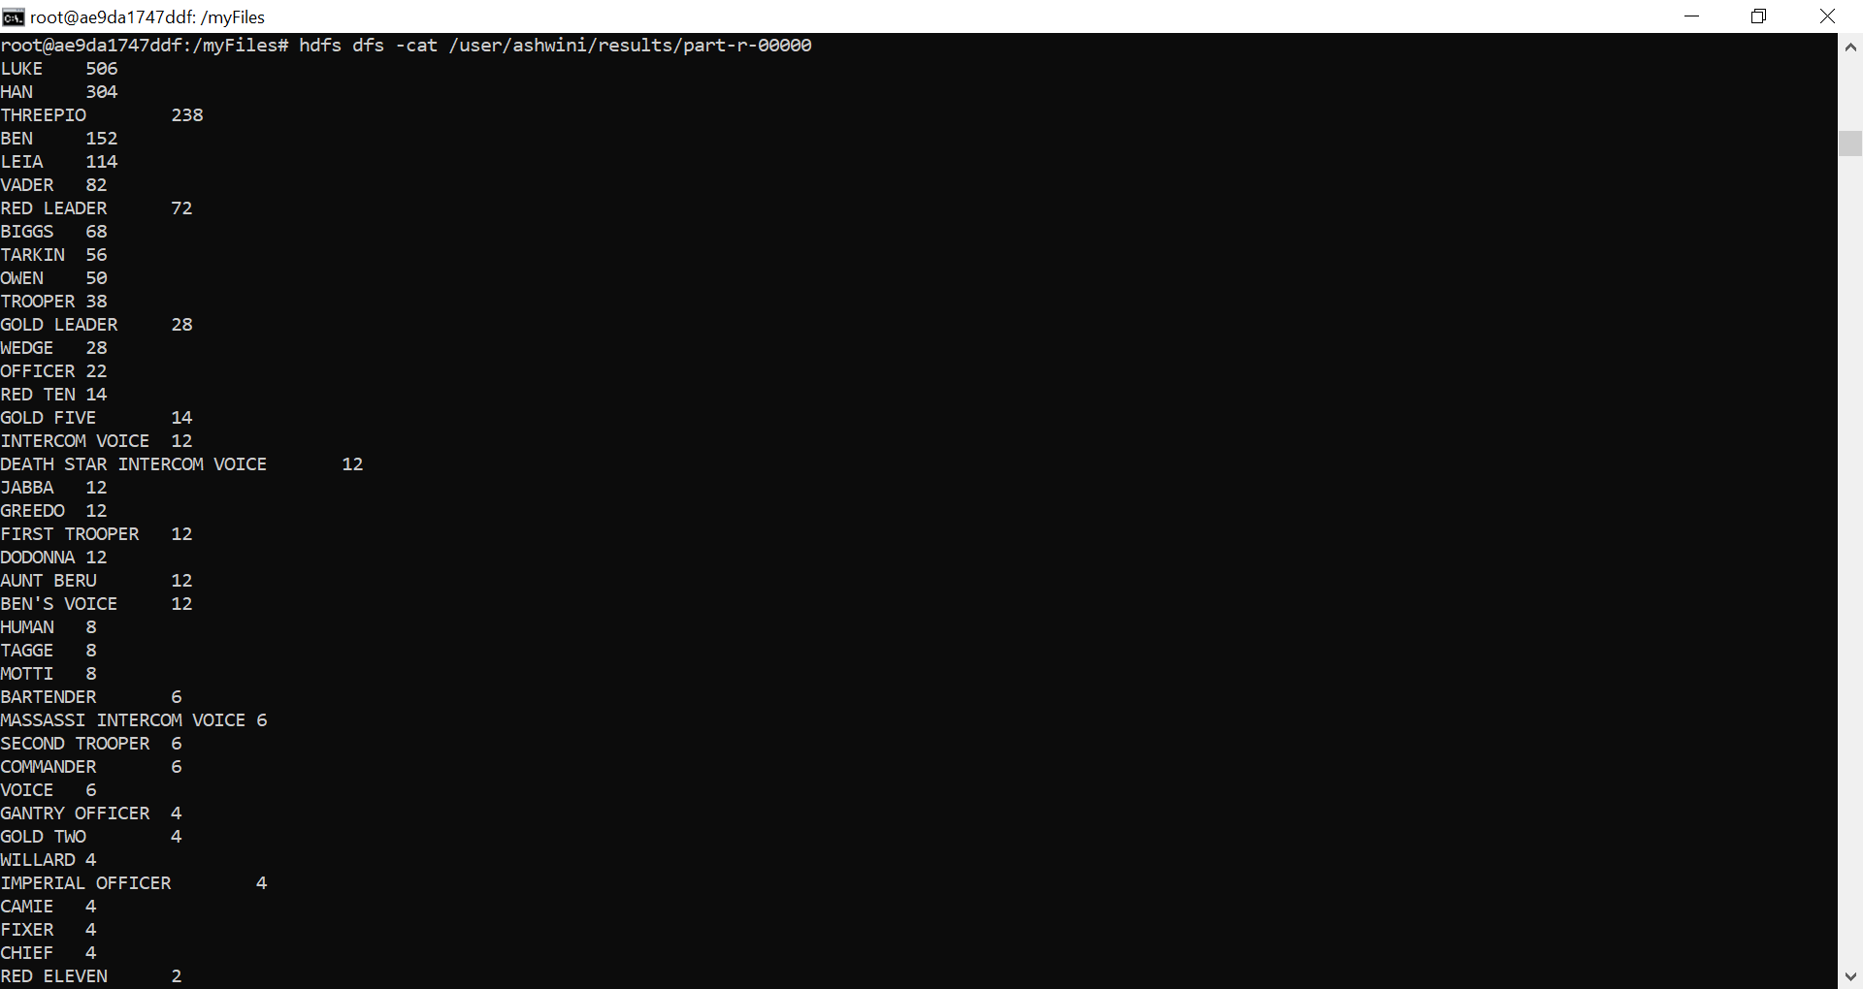

Output for episodeV_dialouges.txt

Output for episodeVI_dialouges.txt

